**Data Driven Framework:**

While testing any application, we may have to test a functionality with different sets of data. In such cases we can’t embed the data in the test scripts. We have to separate the data from the script. In these cases, we store the data in an external file like an excel file or csv file and read the data from there and this is nothing but data driven framework.

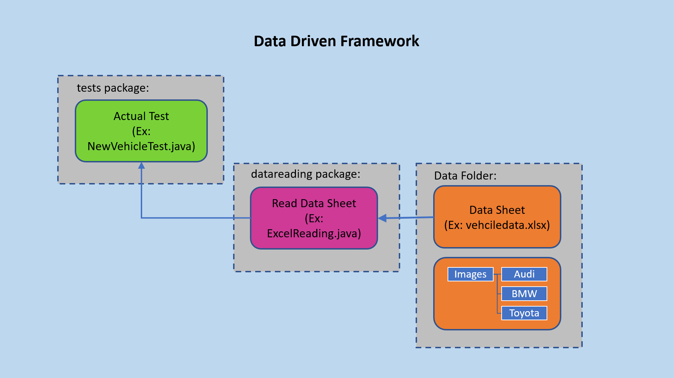

In our sample application let’s say we have to post a vehicle one time in one test script, in another test script we have to post 2 vehicles and in another test script we have to post 3 vehicles. Since it is the same post vehicle steps have to be repeated for a number of times for this particular functionality we separate the data and put it in an excel sheet.

Example Data Sheet:

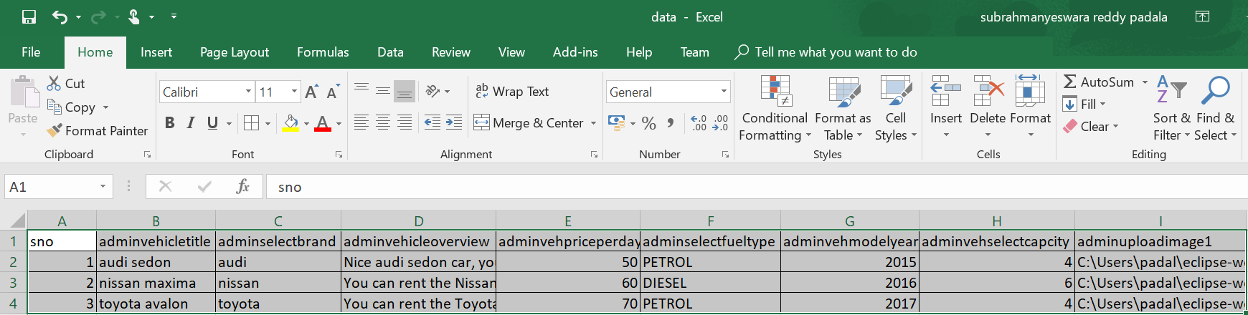

We will create a separate class to read the above data and we will use this class in the main test script we run to pass the data to the functionality.

Pros:

* The most important feature of this framework is that it considerably reduces the total number of scripts required to cover all the possible combinations of test scenarios. Thus, lesser amount of code is required to test a complete set of scenarios.
* Any change in the test data matrix would not hamper the test script code.
* Increases flexibility and maintainability
* A single test scenario can be executed altering the test data values.

Cons:

* The process is complex and requires an extra effort to come up with the test data sources and reading mechanisms.
* Requires proficiency in a programming language that is being used to develop test scripts.